Python Interview Questions:

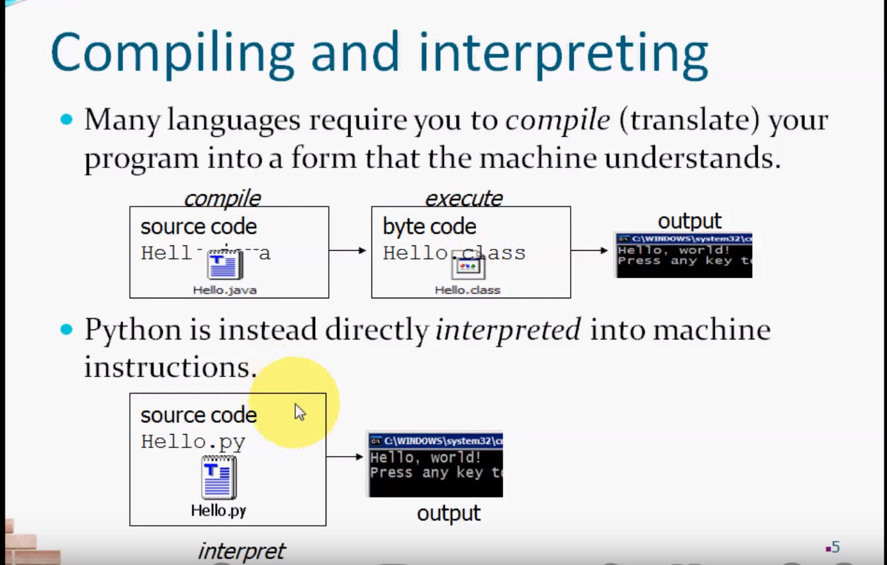

************************************SONY**************************************
1.What is list , tuple and dictionary in Python ?
List
– It is a hybrid data type it contains diff data types (strings, char, number, fraction num, complex num). All the data types into list
It is defined in []
Lists are mutable – we can update, add , delete
In Lists starting position starts with “0” and Ending positions starts with “-1”
Example : lst =[1,2,3,’abc’,2.5,0]
Tuple
-Tuples are created or used with in () and can store multiple values
Tuples are Immutable – we can not update, add ,delete the tuple values
Tuples are used to store sensitive data
We can access the data by using index
Example : t =(1,2,3,test,2.0)
Dictionary
-Dicts is collections of key ,Value Pairs and It is used to represent the meaning full data
Dict are Mutable – able to update, delete and insert
Dict are defined in {}
Example : { ‘name’: ‘Roger’, ‘Empno’: 10001, ‘dept’: “IT’}
Note: Can we Boolearn operator as a Key in Dict → Yes False : ‘OK’
Note:Can we use duplicate keys in dict → Yes we can ,but it will overwrites
Set
-It is used to store unique Values . it is defined in {}
Sets are Mutable- we can update delete and insert
Example : empid =(1,2,3,3,4,4)
result =set(empid)
Print(result) --→ {1,2,3,4}

2.What is Self?
Self – It is used to refer the instance of the class , based on the self only , the method get to know for which instance to call
Note: Can we create a method without the self -- > No (It will throws an Error ,’0’ position arg 1 was given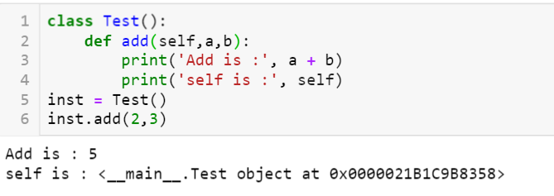

3. L = [1,1,2,2,4] o/p l=[1,2,4] Write a function to get the above output
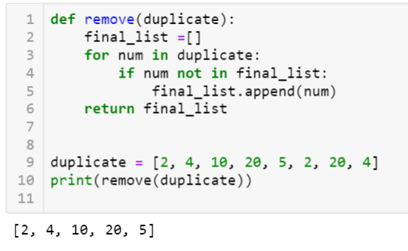
4. num = [1,4,2,7,6,8] o/p =[1,2,4,7,6,8] Write a funtion to sort the numbers
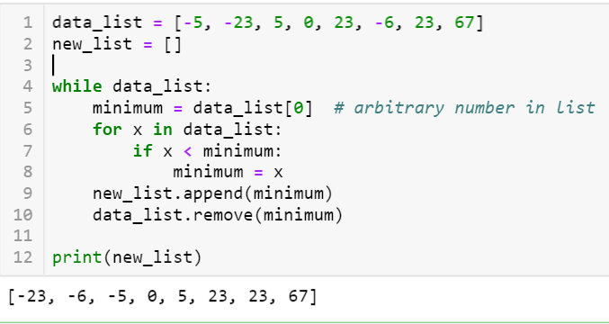
5. How to open the text file and read the data from the File
f = open("demofile.txt", "r")
print(f.read())

1.What is Lambda Function in Python
Lambda Function is called as anonymous function.
Normally we define a function with ‘def’ keyword with function name
Example:
def test_fun():
print(‘This is Function)
test_fun()

In python we can create anonymous function – function without the name .
If you want use a function only once then we will use the lambda function and we have only one expression .
Note: We can pass n num of arguments but we need to use only 1 Expression
Example:
f=lambda a : a*a
result = f(5)
print(result)
o/p - 25
f=lambda a ,b : a + b
result = f(1, 2)
print(result)
o/p – 3

HCL

1.What is lambda function in Python ?
The Lambda function / Operator is to create a anonymous functions i.e., functions with out name
What is the use of lambda function in Python ?
These lambda functions throw-away functions i.e., they are just needed where they have been created.
Note: lambda operator / function can have any num of arguments , but it can have only one expression .
It cannot contain any statement and it returns a function object which can be assigned to any variable

Syntax :
lambda argument list : expression
arguemnt_list – comma separated list of arguments
expression – arithmetic expression
you can assign the function to a variable to give it a name
----------------------------------------------------------------------------------------------------
Example :
sum =lambda x, y : x + y
sum(3,4)
o/p = 7
-----------------------------------------------------------------------------------------------------
Another way of achieving the above one
def sum(x, y):
return x + y
sum(3, 4)

What is filter ?
Python 2 we can use the map ,reduce and filter without using “list”
Note: below examples will work on only python2
Using lambda Filter lets us filter in some values based on conditional logic.
If return value is TRUE then only it stores

Syntax: filter(function, sequence)
Normal function :
def is_even(n):
n%2 == 0
-------------------------------------------------
Nums = [3,2,6,8,2,9]
evens = list(filter(lambda n : n%2 ==0 ,nums))
print(evens) o/p – [2,6,8,2]
What is map ?
map() is function it takes two arguments ,
Map applies a function to every element in an iterable.
map() returns a iterator
syntax : map(fun, seq)
Example :
doubles = list(map(lambda n : n*2 ,even))
print(doubles) o/p – [4,12,16,4]
What is reduce ?
Reduce repeatedly reduces a sequence pair-wise until we reach a single value
sum = reduce(lambda a, b : a +b ,doubles)
print(sum ) – 4+12+16+14 -→ 46
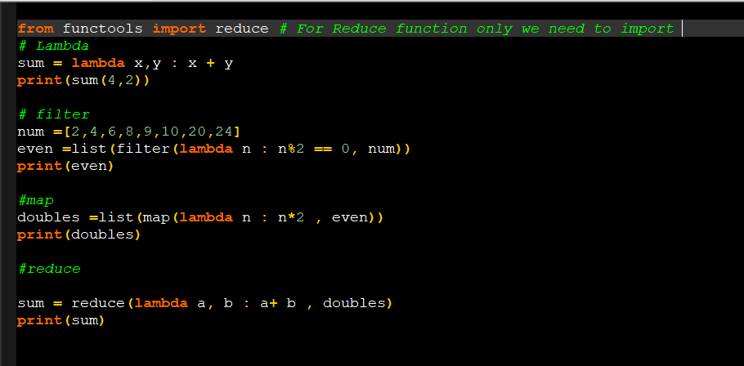
In Python 2.7
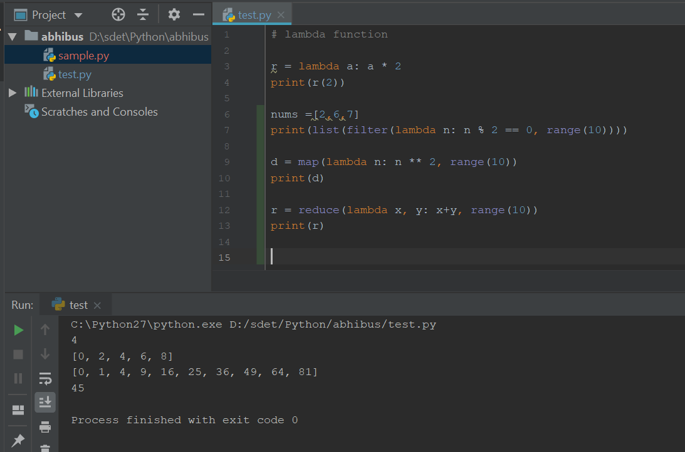
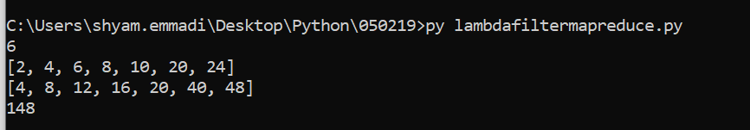

3.What is List comprehensive?
With the help of list comprehensive we can create of list in one line
It consists of brackets containing an expression followed by a for clause or if clause
The list comprehensive always returns a result list
Syntax:

[ expression for item in list if conditional]
Example 1: using for clause
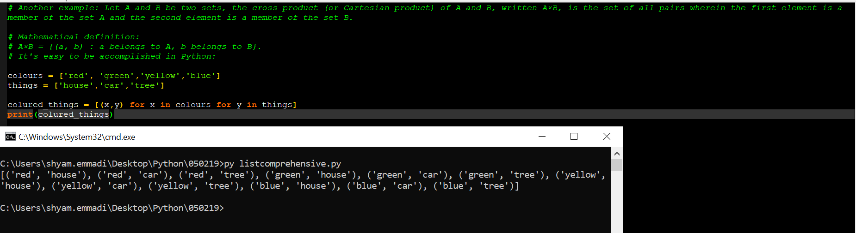
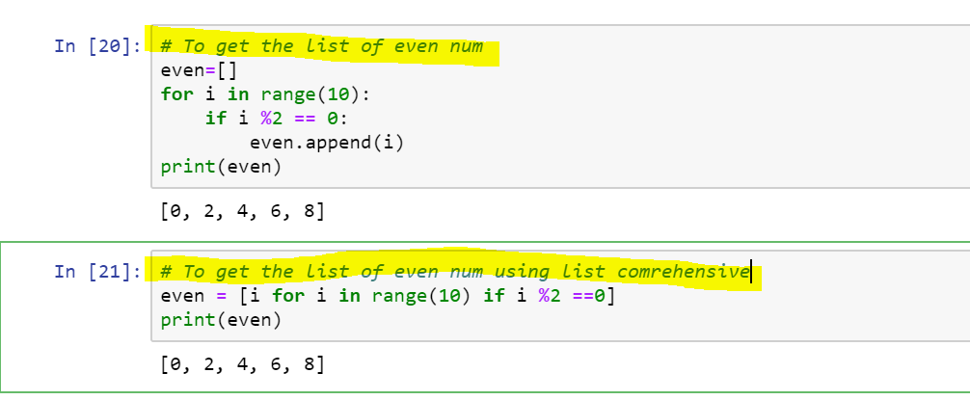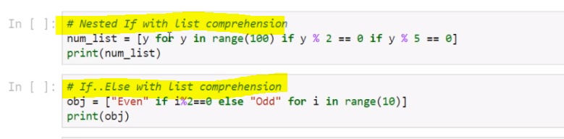

What is zip()?The purpose of zip() is to map the similar index of multiple containers so that they can be used just using as single entity.
Syntax : zip(*iterators)
Parameters : Python iterables or containers ( list, string etc )
Return Value :Returns a single iterator object, having mapped values from all the
containers.

Example : (Python27)
# initializing lists
name = [ "Manjeet", "Nikhil", "Shambhavi", "Astha" ]
roll_no = [ 4, 1, 3, 2 ]
marks = [ 40, 50, 60, 70 ]

# using zip() to map values
mapped = zip(name, roll_no, marks)

# converting values to print as set
mapped = set(mapped)

# printing resultant values
print ("The zipped result is : ",end="")
print (mapped)

# To Unzip the values
name = zip(*mapped)
print(name)

eid = zip(*mapped)
print(eid)

sal=zip(*mapped)
print(sal)

Dictionary Comprehensions:
A dictionary comprehension takes the form {key: value for (key, value) in iterable}
Convert the 2 lists into dictionary

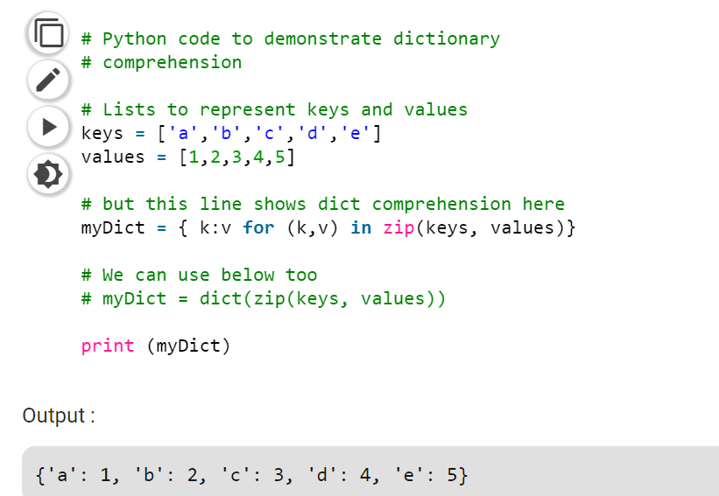

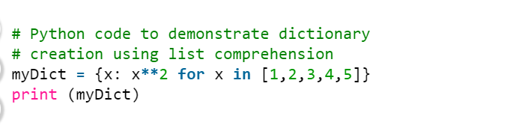
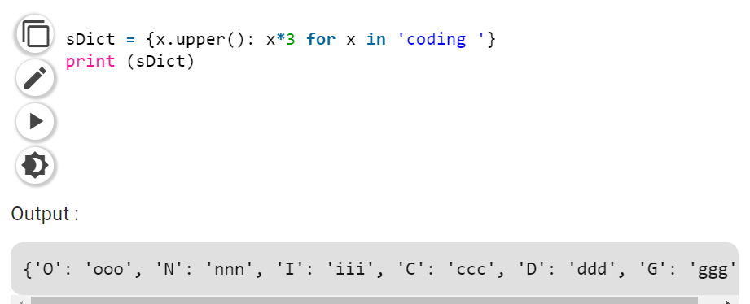

What is the diff between range() and xrange() in PYTHON 2:
Syntax: range(start,end,step)
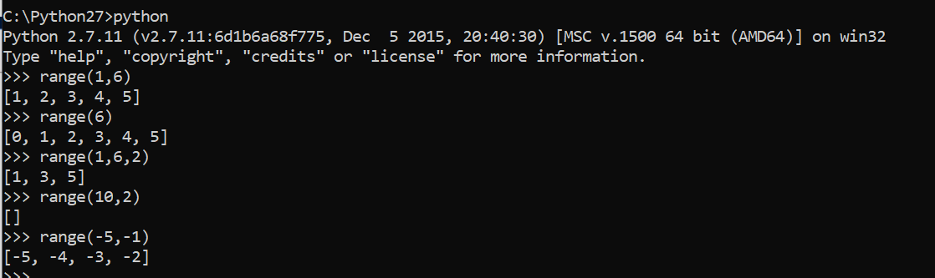

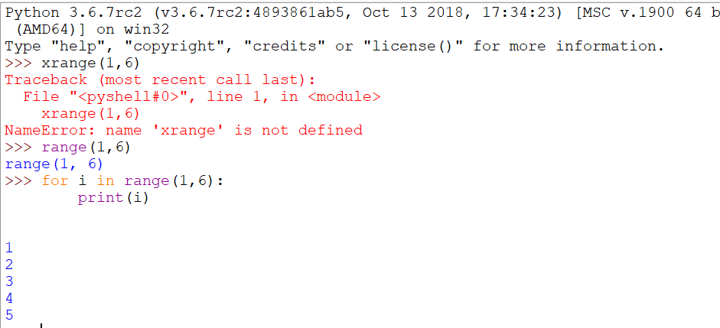
Range() : xrange():
1. It will return list of numbers 1.It will return generator object
range(1,4)
[1,2,3] To print the values need to use for loop for i in xrange(1,4): print i
o/p : 1
2
3
2.It will take more memory space 2. It will take less memory space
3.We can apply List operation 3. We can’t apply any list operations
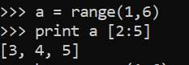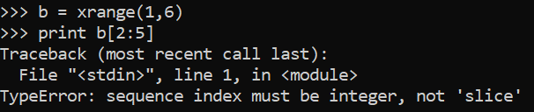

4. running the range() is faster 4.running the xrange() is slower
5.It will generate the values and stores 5.Only object – Iterate one by one value
In memory allocated at a time

Note: There is no xrange() in PYTHON3 ,it has only range() .xrange() renamed in python 3 as range().It will act same as xrange() -PYTHON2

2.What is set operators ? what is the use of set operators? How to remove duplicate values in Python?
→ It is used to store unique Values
→By using set , we can do the set operations
→ It doesn’t support for Index
It’s define in {} or () separated with ‘,’ ,set results are in { }
Eid ={1,2,3,3,4,4,5,5,’Roger’,’Roger}
Print(eid)
o/p –{1,2,3,4,5,’Roger’}
************************
eid =(1,2,2,2,3,4,4)
s =set(eid)
print(s)
o/p-{1,2,3,4}

4. What are Decorators ?
“A Decorator is a Function ,which can take other function as input and providing some output function with extended functionality ”
What is use of Decortor?
Without modifying the existing functionality , we can extended the It’s Functionality
Decorator is a function
It takes another function and extends the behavior of the later function without explicitly modifying it.The decorator acts like a wrapper .
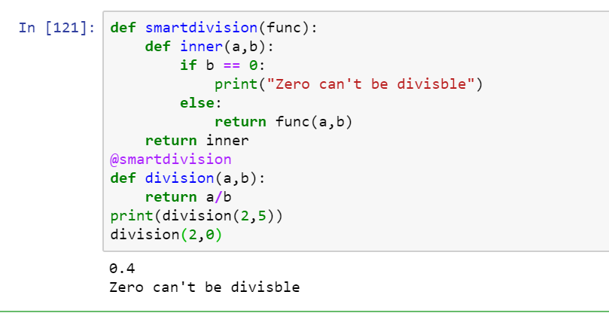

Note: Can we call the function with decorator and without decorator ?
Yes we can call the function with and without decorator
What is iterators in Python?
An Object that can be iterated Upon.
An Object which will return data ,one element at a time
Iterator object must be implement with two methods __iter__() and __next__()
An Object is called iterable if we can get an iterator from it.
Most of built-in containers in Python like : list ,tuple,dict,set are iterables
Note: iter() function (which in turn calls the __iter__() method) returns an iterator from them .
Note : set and dict does not support for indexing [WHILE LOOP]
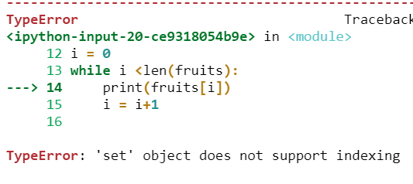
Example :
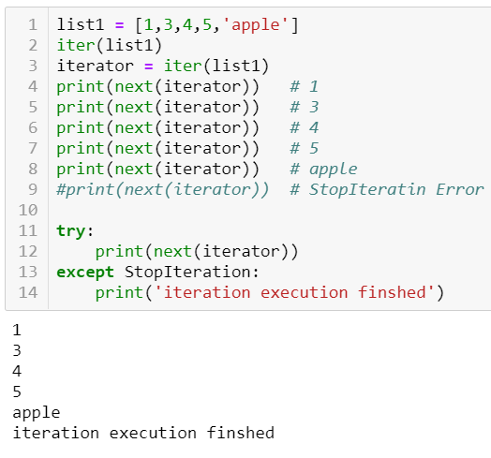
Example : Use "for" loop instead of calling next

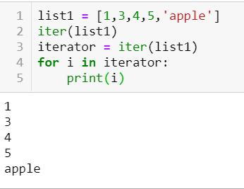

What is Generator function in Python?
To Generate sequence of Values we will use the Generator function by using YIELD keyword and NEXT
“Generator function is a function which returns generator-iterator with help of YIELD Keyword
Note: All the generator-iterators are generators ,but not all the iterators are Generators
Notes:
1. Memory utilizataion will be improved and performance wise faster
2.When we compare with the normal iterators ,genarators are easy to use
3. Genarators is best for webscrapping
Example -What is Febonaci Number
“The sum of the two preceding numbers. The simplest is the series 1, 1, 2, 3, 5, 8,”
What is YIELD:
Yield same as return statements it will return and will continue the statements
Yield will not terminate the Function .

Example : To Generate Fibnaci Numbers
# Febonaci number
def febn():
a,b = 0,1
while True:
yield a
a,b = b , a+b
for n in febn():
if n > 100:
break
print("Feb Num:", n)
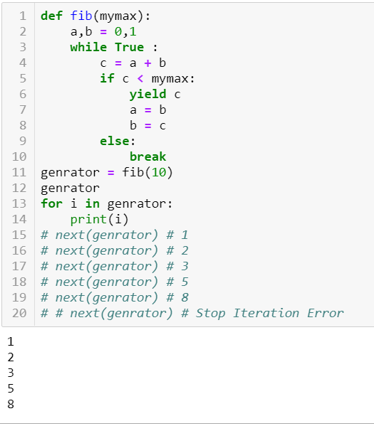

Difference between iterators and generators
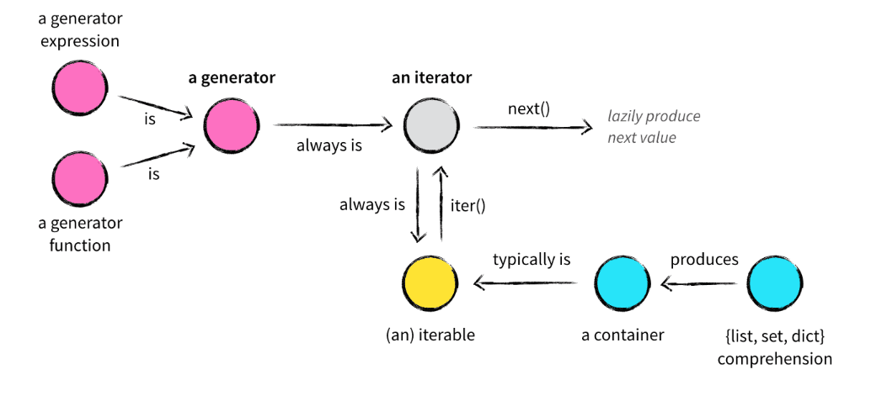

What is difference between function and method in python?
Python Method:
- Method is called by its name, but it is associated to an object (dependent).
- A method is implicitly passed the object on which it is invoked.
- It may or may not return any data.
- A method can operate on the data (instance variables) that is contained by the corresponding class

# Python 3 User-Defined Method
class ABC : /////
def method_abc (self):
print("I am in method_abc of ABC class. ")

class_ref = ABC() # object of ABC class
class_ref.method_abc()

function:
- Function is block of code that is also called by its name. (independent)
- The function can have different parameters or may not have any at all. If any data (parameters) are passed, they are passed explicitly.
- It may or may not return any data.
- Function does not deal with Class and its instance concept.

def Subtract (a, b):
return (a-b)

print( Subtract(10, 12) ) # prints -2

print( Subtract(15, 6) ) # prints 9

What is Garbage collection in Python ?
1.To destroy unused/useless objects
When we say that the object is eligible for garbage collection?
If and only if that the Object doesn’t contain any reference Variables
How to enable or disable the GC in our Program?
By default gc in enabled in Python
Import gc
gc.isenabled() -TRUE
gc.disable()
gc.isenabled() -FALSE
gc.enable()
gc.isenabled() -TRUE
gc.enable() _TRUE
What are destructers ?
Constructor : __init__(self)
Destructers: __del__(self)
- To perform Cleanup activity then destroy the object
- Closing database connections
Creation (Object : Object creation)→ Constructor (To Perform Intialization)→Use that Object →destructor(To Perform cleanup activity) →GC Destroy the Object
How to find no.of references to an Object?
Note : Internally self also an reference object hence the total reference objects are 4
Import sys
class Test():
def __init__(self):
print("Creating Intilization object / Constructor Execution")
def __del__(self):
print("Perform Cleanup Activities / Desctructor Execution")
t1=Test()
t2=t1
t3=t2
print(sys.getrefcount(t1))

# Garbase collection Example
import time
class Test():
def __init__(self):
print("Creating Intilization object / Constructor Execution")
def __del__(self):
print("Perform Cleanup Activities / Desctructor Execution")
t1=Test()
t2=t1
t3=t2
del t1
time.sleep(10)
print("Object not yet destroyed after deleting t1")
del t2
time.sleep(10)
print("Object not yet destroyed after deleing t2")
del t3
time.sleep(10)
print("End of Application ")

Given two strings s1 and s2, check if both the strings are anagrams of each other.
Examples:
Input : s1 = "listen"
s2 = "silent"
Output : The strings are anagrams.

Input : s1 = "dad"
s2 = "bad"
Output : The strings aren't anagrams.
Python provides a inbuilt function sorted() which does not modify the original string, but returns sorted string.
Below is the Python implementation of the above approach:
# function to check if two strings are
# anagram or not
def check(s1, s2):

# the sorted strings are checked
if(sorted(s1)== sorted(s2)):
print("The strings are anagrams.")
else:
print("The strings aren't anagrams.")

# driver code
s1 ="listen"
s2 ="silent"
check(s1, s2)
Output:

The strings are anagrams.

A Program to check if strings are rotations of each other or not
Given a string s1 and a string s2, write a snippet to say whether s2 is a rotation of s1?
(eg given s1 = ABCD and s2 = CDAB, return true, given s1 = ABCD, and s2 = ACBD , return false)

Algorithm: are Rotations(str1, str2)
1. Create a temp string and store concatenation of str1 to
str1 in temp.
temp = str1.str1
2. If str2 is a substring of temp then str1 and str2 are
rotations of each other.

Example:
str1 = "ABACD"
str2 = "CDABA"

temp = str1.str1 = "ABACDABACD"
Since str2 is a substring of temp, str1 and str2 are
rotations of each other.

# Python program to check if strings are rotations of
# each other or not

# Function checks if passed strings (str1 and str2)
# are rotations of each other
def areRotations(string1, string2):
size1 = len(string1)
size2 = len(string2)
temp = ''

# Check if sizes of two strings are same
if size1 != size2:
return 0

# Create a temp string with value str1.str1
temp = string1 + string1

# Now check if str2 is a substring of temp
# string.count returns the number of occurences of
# the second string in temp
if (temp.count(string2)> 0):
return 1
else:
return 0

# Driver program to test the above function
string1 = "AACD"
string2 = "ACDA"

if areRotations(string1, string2):
print "Strings are rotations of each other"
else:
print "Strings are not rotations of each other"
4. What is switch in Python ?
5.How Memory Allocation / Memory managed works in Pyhon
Dynamic memory allocation
6.What is mocking in unit testing ?
7. Mention why to choose Python over Java in Selenium?
Few points that favor Python over Java to use with Selenium is,
Java programs tend to run slower compared to Python programs.
Java uses traditional braces to start and ends blocks, while Python uses indentation.
Java employs static typing, while Python is dynamically typed.
Python is simpler and more compact compared to Java
8.How create a branches in Github?
>git branch # It will give all the branches
*Master
> git branch [branch name] thirsty
>git branch
*Master
Thirsty
>git checkout thirsty [To make thirsty branch active ]
Switched to branch thirsty
>git branch
*Master
*thirsty
9.How to rename the one file in github command , what is the command ?
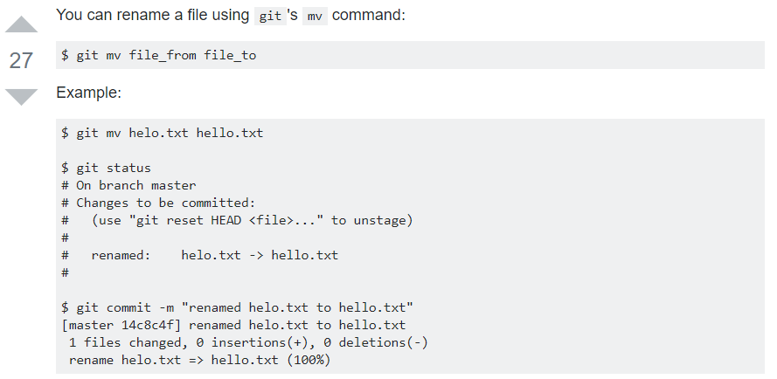10.What is difference between svn and github ?
GitHub svn
1.Git is distributed VCS 1.SVN is non-distributed VCS
2.Git has a Centralized server and repo 2.SVN does not have centralized server and repo
3.The Content in Git is stored in meta data 3.SVN stores files of content
4.Where using Git ,we can have local repo 4.We don’t have local repo
4.Git branches are easier to work with than SVN branhes
Apple:

1.parse a csv file and
extract the name, phone numebers, emails into a dict.
2. 1. How would I test a new drag-n-drop feature
3. I was given an iPad and asked to explain my general test automation strategy, then select one particular area, write test cases, a test class and a code
4. How would I test the entire API
5. What is the purpose pass statement in Python?
# pass is just a placeholder for functionality to be added later.
Suppose we have a loop or a function that is not implemented yet, but we want to implement it in the future. They cannot have an empty body. The interpreter would complain. So, we use the pass statement to construct a body that does nothing.
sequence = {'p', 'a', 's', 's'}
for val in sequence:
pass

6. How do you look for locators on a page (have you used any tools?)

IBM:
1.What is decorator
2.What is Listeners
3.In JSON Response How to get the specific record in dict? Here I want to get the id = 432
D ={
“name”: “abc”
“id”: 123
“name1”:222
“id”: 432
}
4.Write a method to iterate the values in dict ?
5.how to connect to db using python ? and get the table name
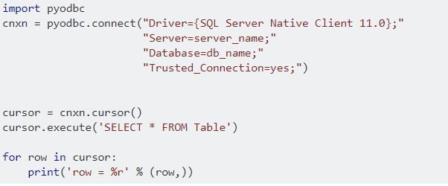

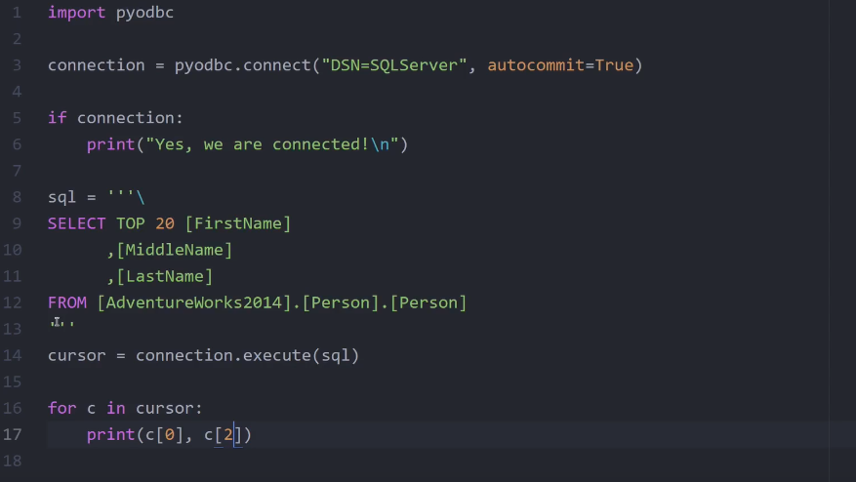
6.What are all Assertions?
AssertEqual ,AssertEquals, AssertNotEqual
AssertTrue, AssertFalse
AssertAlmostEqual, AssertAlmostEquels
AssertGreater,AssertGreaterEquel
AssertIn,AssertRises
What are All Exceptions?
NosuchElementException
NoSuchAlertPresentException
NoSuchFrameException
NoSuchWindowException
ElementVisibleException
ElementnotSelectedException
InvalidSelectorException
TimeoutException
SeeionNotFoundException
WebdriverException
StaleElementRefrenceException

- ElementNotVisibleException: Although an element is present in the DOM, it is not visible (cannot be interacted with). E.g. Hidden Elements – defined in HTML using type=”hidden”.
- ElementNotSelectableException: Although an element is present in the DOM, it may be disabled (cannot be clicked/selected).
- InvalidSelectorException: Selector used to find an element does not return a WebElement. Say XPath expression is used which is either syntactically invalid or does not select WebElement.
- NoSuchElementException: WebDriver is unable to identify the elements during run time, i.e. FindBy method can’t find the element.
- NoSuchFrameException: WebDriver is switching to an invalid frame, which is not available.
- NoAlertPresentException: WebDriver is switching to an invalid alert, which is not available.
- NoSuchWindowException: WebDriver is switching to an invalid window, which is not available.
- StaleElementReferenceException: The referenced element is no longer present on the DOM page (reference to an element is now Stale). E.g. The Element belongs to a different frame than the current one OR the user has navigated away to another page.
- SessionNotFoundException: The WebDriver is performing the action immediately after ‘quitting’ the browser.
- TimeoutException: The command did not complete in enough time. E.g. the element didn’t display in the specified time. Encountered when working with waits.
- WebDriverException: The WebDriver is performing the action immediately after ‘closing’ the browser.

7.How do you get to know wheather the textbox is able to enter text or not ?
Element.is_enabled()
8.After peer review the code , if you need to do some changes -> after some changes how to commit back it again ?
9.What area all RESTAPI methods ?
10.Tell me about Your Framework
11.how to take screenshot for single iteration in python

Differences between remove(), delete() and pop()
remove - Takes value, removes first occurrence, and returns nothing
delete - Takes index, removes value at that index, and returns nothing
pop - Takes Index and returns Value
# Remove - remove removes the first matching value, not a specific index:
A=[0,2,3,2]
a.remove(2)
a →[0,3,2]
--------------------------------------------------------------------------------------------------------------------
# del Deletes the item at specific index
B =[3,2,2,1]
Del b[1]
b→[3,2,1 ]
------------------------------------------------------------------------------------------------------------------------
# pop, removes the item at a specific index and returns it
P =[4,3,5]
a.pop(1)
a→[4,5]
-------------------------------------------------------------------------------------------------------------------------

1.What is Python? What are the benefits of using Python?

Answer: Python is a programming language with objects, modules, threads, exceptions and automatic memory management. The benefits of pythons are that it is simple and easy, portable, extensible, build-in data structure and it is an open source.

2. How Python can be used in software testing?

Answer:
1. To generate test data; parse test results; generate reports; testing API calls etc.
2. Python to extract requirements from a Word document.
3. For testing tasks automation, setting up environments for tests, extracting performance data, etc…
4. Testers use Python extensively in many companies with Selenium for test automation.
5. For writing desktop applications used by testers.
6. Test data manipulation.
7. To build test environment
8. Testing with IronPython on .NET

3.What Python frameworks do you know?

Answer: Framework called Web2py, PAMIE (Python automation Module for I. E.), The py.test framework

4.Question:What tools that helps Python development do you know?

Answer:There are good tools for helping Python development such as Notepad++ with the PyNPP plugin and Eclipse with PyDev and PyUnit.

5. The following is displayed by a print function call:
yesterday today tomorrow Please write an example of a print function.

Answer: print(‘yesterday\ntoday\ntomorrow’)

6.The following is displayed by a print function call:

Answer:hello-how-are-you

7. Please write an example of a print function.
Answer: print(‘hello’ + ‘-‘ + ‘how’ + ‘-‘ + ‘are’ + ‘-‘ + ‘you’)

8. What does the expression len(”) evaluate to?
Answer: 0

9.Considering the following code:
s = ‘catandapple’
Write an expression that evaluate to ‘apple’.
Answer: s[-5:]

10.Write an expression that evaluate to True
Answer: len(‘aaddgg’) == 6

12.What are “tuples”
Answer: Tuples are immutable sequences: they cannot be modified. Tuples use parentheses instead of square brackets: tup = (‘test’, 5, -0.2)

13. What are the rules for legal Python names?
Answer:
1. Names must start with a letter or _.

2. Names must contain only letters, digits, and _.

14.. Which command do you use to exit help window or help command prompt?

quitWhen you type quit at the help’s command prompt, python shell prompt will appear by closing the help window automatically

15. Does the functions help() and dir() list the names of all the built_in functions and variables? If no, how would you list them?

No. Built-in functions such as max(), min(), filter(), map(), etc is not apparent immediately as they are
available as part of standard module.To view them, we can pass the module ” builtins ” as an argument to “dir()”. It will display the
built-in functions, exceptions, and other objects as a list.>>>dir(__builtins )
[‘ArithmeticError’, ‘AssertionError’, ‘AttributeError’, ……… ]

16. Explain how Python does Compile-time and Run-time code checking?

Python performs some amount of compile-time checking, but most of the checks such as type, name, etc are postponed until code execution. Consequently, if the Python code references a user -defined function that does not exist, the code will compile successfully. In fact, the code will fail with an exception only when the code execution path references the function which does not exists.

17.What is a “unittest” in Python?

The unit testing framework of Python is known as “unittest”. It supports the sharing of setups, automation testing, shutdown code for tests, aggregation of tests into collections, among others.

18.Define “slicing”.

“Slicing” is a mechanism to select a range of items from sequence types like list, tuple, strings etc.

19.What are generators in Python?

Generators are the means to implement iterators. It is a normal function except that it yields “expression” in the “function”.

20.Define “docstring”.

“Docstring” is a Python documentation string. It is the means to document Python “functions”, “modules” and “classes”.

21.How do you copy an object in Python?

copy.copy () or copy.deepcopy()

22.What is a “negative index”?

Python sequences can be indexed as positive and negative numbers. For ac positive index, 0 is the first number, 1 is the second etc. For a negative index, (-1) is the last index and (-2) is the second etc.

23.How do you convert a number into a string?

By using the inbuilt function str().

24.What is the difference between “Xrange” and “range”?

“Xrange” returns the “Xrange” object
while range returns the “list” irrespective of the size of the “range”.

25.Define “module” and “package”.

Each Python program file is a “module”, which imports other modules like “objects” and “attributes”.

A Python program folder is a “package” of “modules”. A package can have “modules” or “subfolders”.

26.What is Python? What are the benefits of using Python?

Python is a programming language with objects, modules, threads, exceptions and automatic memory management. The benefits of pythons are that it is simple and easy, portable, extensible, build-in data structure and it is an open source.

27.What is PEP 8?

PEP 8 is a coding convention, a set of recommendation, about how to write your Python code more readable.

28.What is pickling and unpickling?

Pickle module accepts any Python object and converts it into a string representation and dumps it into a file by using dump function, this process is called pickling. While the process of retrieving original Python objects from the stored string representation is called unpickling.

29. How Python is interpreted?

Python language is an interpreted language. Python program runs directly from the source code. It converts the source code that is written by the programmer into an intermediate language, which is again translated into machine language that has to be executed.

30. How memory is managed in Python?

Python memory is managed by Python private heap space. All Python objects and data structures are located in a private heap. The programmer does not have an access to this private heap and interpreter takes care of this Python private heap.
The allocation of Python heap space for Python objects is done by Python memory manager. The core API gives access to some tools for the programmer to code.
Python also have an inbuilt garbage collector, which recycle all the unused memory and frees the memory and makes it available to the heap space.

Convert the list into Dict
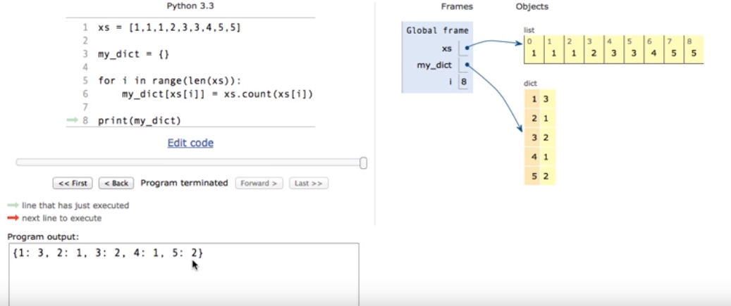

What are Python functional arguments
There are 4 types of Functional arguments
1.Required or Positional Arguments
2.Keyword arguments
3.Default Arguments
3.Variable Length Arguments *args and **kwargs

1.Required and Positional Arguments
“Required arguments are the arguments passed to a function in correct positional order. Here, the number of arguments in the function call should match exactly with the function definition.”
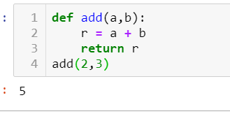
You must pass at least argument other wise it will throw positional argument error

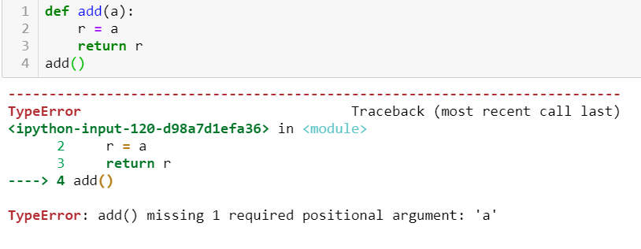

2. Keyword Arguments
“Keyword arguments are related to the function calls. When you use keyword arguments in a function call, the caller identifies the arguments by the parameter name.”
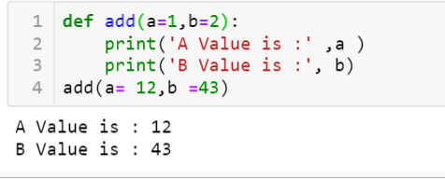

3.Default Arguments
“A default argument is an argument that assumes a default value if a value is not provided in the function call for that argument.”
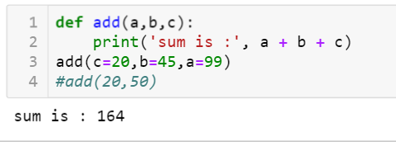
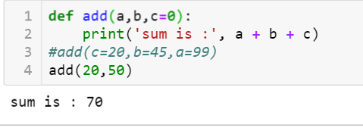
Note: Using Default arguments we can provide a default value to the parameters
Note1:If you don’t pass values to parameters then it will take default value
Note2:Default parameters should follow the Required arguments

4.Length Arguemtns
what is args and kwargs or Variable length Arguments
*args -It is used to pass a non-keyworded, variable-length argument list.
the symbol * to take in a variable number of arguments;
Note: It will give the tuple format

Example:
def add(a, b):
r = a + b
return r
print( add(2,3))
o/p – 5
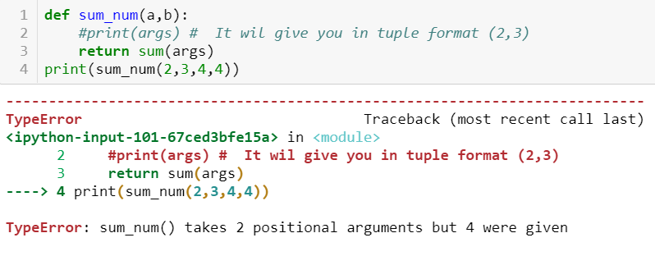
In the above example we are passing only 2 values to function if you print the fun it will return in tuple format
In case if we want to pass n num of values or arguments to fun ,in this scenario we will use * args concept Here * represents “ N” num of non keyword variable arguments passing to function
Example :
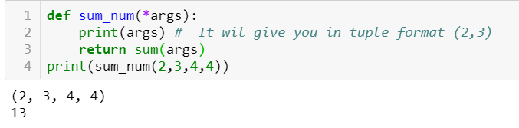
**kwargs-It is used to pass a keyworded, variable-length argument list.
We use the name kwargs with the double star. The reason is because the double star allows us to pass through keyword arguments (and any number of them).
Note : It will give the Dict format i.e. Keys and Values Format
Example:
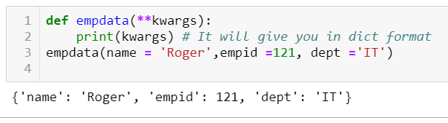

what is diff between unittest and pytest

5. What is the purpose pass statement in Python?
# pass is just a placeholder for functionality to be added later.
Suppose we have a loop or a function that is not implemented yet, but we want to implement it in the future. They cannot have an empty body. The interpreter would complain. So, we use the pass statement to construct a body that does nothing.
sequence = {'p', 'a', 's', 's'}
for val in sequence:
pass

what are concepts are implemented in your framework
what kind of report you are using
what type enhancements are used
what is decorator
what is generator
what is yield
Yield same as return statements it will return and will continue the statements
Yield will not terminate the Function .
What is Return
It will return the given value and terminate the loop
sql

